
EXHIBITOR MANUAL
This manual contains all the necessary information to help you prepare for your participation. We encourage you to read it carefully and to pay close attention to the applicable deadlines. It is advisable to prepare well in advance and not to hesitate to contact us if you have any questions or uncertainties.
We wish you a successful participation.
STANDNUMBER & EXHIBITOR LIST
- Stand number: mentioned in our confirmation mail
The stand number is strictly linked to the confirmed exhibitors. It is prohibited to allow the presence of a second company in the booth space without authorization. Any additional product and/or brand must be reported to the organization in addition to the initial registration.
- List of exhibitors: www.tavola-xpo.be

BUILD UP
Exhibitors building their own stands & stand builders
day hour
wed 11/03/2026 08:00 – 19:00
thu 12/03/2026 08:00 – 19:00
fri 13/03/2026 08:00 – 19:00
sat 14/03/2026 08:00 – 14:00

Exhibitors hiring a shell scheme stand: type Casa, Green, Truss, Matrix, Matrix AKU and Thames
day hour
thu 12/03/2026 13:00 – 19:00
fri 13/03/2026 08:00 – 19:00
sat 14/03/2026 08:00 – 14:00
Exhibitors hiring a shell scheme stand: type Wood, Market, Concept
day hour
fri 13/03/2026 08:00 – 19:00
sat 14/03/2026 08:00 – 14:00
- Earlier start for build-up on Monday 09/03 and Tuesday 10/03 from 8.30am until 5.30 pm. only upon request (550,00 € par day et per stand, excl. VAT)
- Building longer in the evening possible upon request and with written permission from the organizers. No material or equipment may be taken out, outside the official build up hours. Our stewards are authorized to perform any checks that may be necessary.
- Saterday 14/03: Only for the embellishment of the stands and the setup of the exhibited products.
- All stands must be fully completed by Saturday 14/03 at 2:00 PM.
The access doors for construction will close at 2:00 PM. After this time, access will only be possible via XPO ZUID and XPO NOORD.
Placement of large and/or heavy machines on the stands:
= goods or elements which will be difficult to transport to the stand:
- ALWAYS to be reported to the organization in advance
- only possible during the first construction day on Wednesday 11 March, timing in agreement with the organization.

Your Carpet
- A protective film is placed on your carpet, which must be removed by yourself before Saturday, 14/03/2026 at 14:00.
- If removed by the organizer: €2.00/m² (excluding VAT)

Aisles
- On 14/03/2026 from 14:00 onwards, the aisles will be cleaned. Please ensure that nothing is left in the aisles.
- White carpet in the corridors – olive yellow carpet on the central axes.

Ordered Services
- Any complaints regarding unfulfilled services must be made no later than the first day of the trade fair at the exhibition office.
- Complaints made after the fair will not be considered.

EXHIBITION DAYS
VISITOR ACCESS
day hour
sun 15/03/2026 10:00 – 19:00
mon 16/03/2026 10:00 – 19:00
tue 17/03/2026 10:00 – 18:00
- Occupied halls: 1,2,4,5 et 6
- Access: XPO ZUID (via Kennedylaan/Kinepolis) and XPO NOORD (via E17/Parking P6)
- Building closing time : at 20h00, the building will be closed by the steward.
After 20:00, you can go to the lounge bar at the Rambla.

Entry Price – Visitor
- • €40.00 without online registration
- • Free with online registration at http://www.tavola-xpo.be using the code on your invitation card or via the personal registration link from an exhibitor.

ACCESS FOR EXHIBITORS AND STAND TEAMS
Only with an exhibitor badge
day hour
sun 15/03/2026 from 07:00
mon 16/03/2026 from 08:00
tue 17/03/2026 from 08:00

DELIVERY OF PRODUCTS DURING THE EXHIBITION
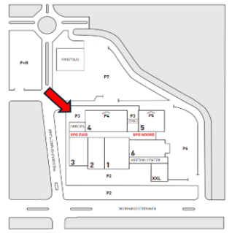
A loading and unloading area is available for morning deliveries to your stand during the exhibition days.
Access is via Parking P3A, with delivery through Xpo ZUID.
day hour
sun 15/03/2026 07:00 – 09:30
mon 16/03/2026 08:00 – 09:30
tue 17/03/2026 08:00 – 09:30
Conditions:
If you deliver but do not stay at the exhibition afterwards:
- You must wear an exhibitor badge.
- To access the loading/unloading area with a vehicle, a minimum deposit of €20.00 is required. A receipt will be provided. If your vehicle leaves the area before 09:30, the deposit will be refunded upon presentation of the receipt.

If you deliver and stay at the exhibition afterwards:
- You must wear an exhibitor badge.
- Van (occupying only one parking space)? It may remain in the Kortrijk Xpo parking areas.
Truck? Trucks are not allowed to remain on the Kortrijk Xpo site and must be parked near the campus (more info to follow).

Need permanent storage for your products?
You can request the installation of a cold room, refrigerated truck, etc., in Hall 3 via the exhibitor portal – under the "webshop" section.
PULL OUT
Exhibitors building their own stands & stand builders hall 1, 2 and 5
day hour
tue 17/03/2026 18:30 – 24:00
wed 18/03/2026 08:00 – 18:00

Exhibitors building their own stands & stand builders hall 4 and 6
day hour
tue 17/03/2026 18:30 – 24:00
wed 18/03/2026 08:00 – 16:00

Exhibitors hiring a shell scheme stand
(Casa, Green, Truss, Wood, Matrix, Taro, Thames, Rhone, Market, Concept)
day hour
tue 17/03/2026 18:30 – 24:00
wed 18/03/2026 08:00 – 10:00
Important!!
The dismantling on Tuesday, 17/03, is organized in collaboration with the Police Services of the City of Kortrijk.

- Vehicles for dismantling gather on President Kennedy Avenue. (see map below)
- Cars and little vans for dismantling are allowed on site starting from 18:00. As soon as there is space available in the parking lots, vehicles in the queue will be directed onto the site.
- Larger trucks and semi-trailers are allowed on the Kortrijk Xpo site from 21:00 onwards.
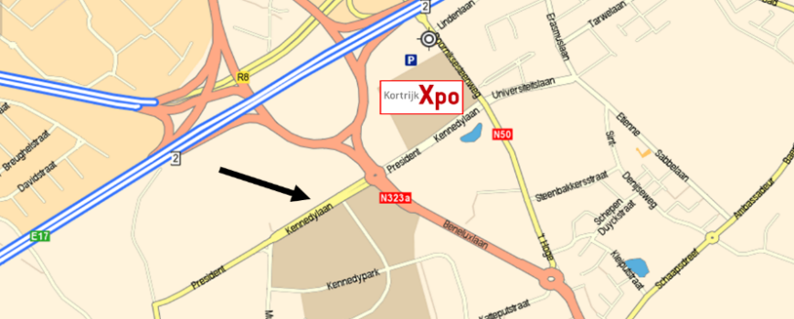
Please adhere strictly to these rules to ensure a smooth and safe dismantling process.

IMPORTANT:
- It is strictly forbidden to start dismantling before 18:00 on 17/03.
- Removal of rented furniture/appliances begins on Tuesday evening, 17/03, from 18:30 onwards.
- Dismantling of rented modular stands starts on Wednesday morning. Please clear the partitions and storage space beforehand.

Theft prevention: During dismantling, it is recommended that at least one person remains at the stand at all times.

INSTRUCTIONS BUILD UP – PULL OUT
ACCES TO THE PREMISES DURING BUILD UP AND PULL OUT
1 permit = 1 vehicle
- will be sent to you digitally. You can print as many copies as needed. If you have provided us with your builder’s contact details, they will also receive a pass.
- This pass is not a parking ticket, but it allows you to park close to the doors for loading and unloading.
- Your build-up and pull-out gate is indicated on the pass.
- The pass must be displayed clearly behind the windshield of each vehicle.
- Persons coming only to supervise the stand construction should park in parking lot P7.
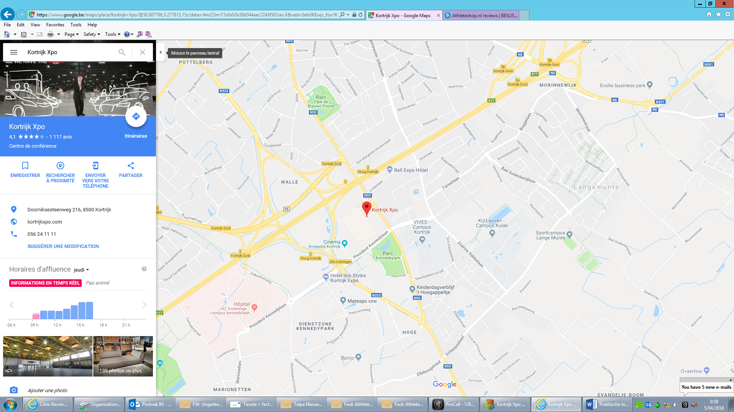

- No trucks or cars allowed inside the halls.
- Please bring your own trolleys for loading and unloading.
- Forklift service must be ordered via the webshop (mandatory through Xpo Group).
- Trucks, trailers, or vehicles occupying more than one parking space:
            - €250.00 per exhibition day if they remain on our parking lots during the event.
            - Free parking available at Beneluxlaan, Condédreef, or the E17 border post (GPS: 50°44’59”N – 3°10’5”E).

ACCESS FOR PERSONNEL DURING BUILD UP – PULL OUT
- Registration is mandatory at the Xpo Zuid Fair Office (Kinepolis side).
- Wearing work bracelets is compulsory for everyone inside the building – this is checked as part of theft prevention.
- For exhibitors, pull out is also possible using the exhibitor badge.

Exhibitor badges: will NOT be sent in advance. Shortly before the event, after payment confirmation, you will receive a link allowing you to print your badges yourself.
Access to the halls is only permitted after full payment of all invoices (stand rental and services). Payments must be made by bank transfer:
- BNP Paribas Fortis: IBAN: BE76 2850 5821 6395 – BIC: GEBABEBB
- KBC: IBAN: BE54 4696 1243 4197 – BIC: KREDBEBB
Late orders: Payment on-site by credit card is possible.

SUBMISSION OF STAND DESIGN/PLAN
Participants planning their own stands must submit a stand plan to the organization by 27 January 2026, addressed to:
              - Hall 1, 2 & 6: Annelies Detavernier – anneliesdetavernier@xpogroup.com
              - Hall 4 & 5: Ellen Naessens - ellennaessens@xpogroup.com
Please take the following into account:
- Indicate water and electricity connections on the hall’s technical plan for your stand configuration. See the exhibition plan on the exhibitor portal – under the “Technical Plans” section.
- The locations of the various pillars in the halls: http://www.kortrijkxpo.com/space-for-fairs

FLOORING & SEPARATION WALLS - STAND HEIGHT & ELEVATED FLOOR
Flooring and partition walls must be provided by you or can be ordered via the webshop.
- The standard construction height is 2.50 m.
If you plan to build higher than 2.50 m (up to a maximum of 6.00 m), you must submit a stand plan. After approval to build higher, the rear of your stand must have a clean, neutral finish (white, black, or grey – no logos or promotional content).
If this is not properly finished by the final day of setup (by 14:00), the exhibition organizer will ensure it is completed at the exhibitor’s expense.
- For suspended elements or parts of the stand higher than 2.50 m that are not neutral (with colors, logos, or other promotional content), a minimum distance of 1 m from neighboring stands must be maintained.
Neutral elements (white, black, or grey without branding) above 2.50 m can be built directly against the rear wall of the neighboring stand.
- Stand with an upper floor: extra fee of €750.00 (including inspection costs).
- If you plan to install a raised floor in your stand, make sure to include a gentle ramp so the stand is accessible for wheelchair users.

RESTRICTIONS ON CLOSING OFF PERIMETER WALLS OF YOUR STAND
No more than 60% of the length of any side of a stand adjacent to an aisle may be closed off. Any walls adjacent to an aisle must be finished in an attractive way.
CONNECTIONS TO THE WATER GRID AND ELECTRICITY GRID OF KORTRIJK XPO
The connection of the stand to the electricity grid (: distribution box) and to the water grid of Kortrijk Xpo needs to be accessible at all times. For example, if the connection to the input and the output of the water grid is situated under your heightened floor, you need to make sure that the floor boards can be removed, also during the fair itself.
- Important: "Order a sufficient capacity based on the configuration of the devices to be connected (e.g., 5 sockets × 150 watts + coffee machine 1,500 watts + display lighting 150 watts, etc.). Take into account a safety margin for the additional power consumed by devices when they start up."

STANDBY SERVICE FROM OUR SUPPLIERS
The suppliers of the material/services you ordered through Kortrijk Xpo will be available to answer your questions and help you solve any problems at the following times:
- Shell scheme stands: during build up
- Electricity and water: during build up, opening days and clearing out
- Refrigerators: during opening days

INSPECTION OF ELECTRICAL EQUIPMENT
An electrical connection inspection will be carried out by an official body (EDTC).
If personal electrical equipment or equipment rented from a stand builder is used (electrical panel, spotlights, sockets, etc.), the inspection costs will be charged to the exhibitor or stand builder (at a rate of €26.50 per 16 m², with a maximum of €132.50).
FORKLIFT
Please always report to the fair office when you need a forklift – even if it has been ordered in advance.
Advance orders will always take priority over on-site requests.
The use of forklifts rented from external companies or personal forklifts is not permitted.
Let me know if you'd like to use more formal or technical terms.

SUSPENSIONS
Please refer to the Kortrijk Xpo Safety Manual, Part B, available on our Exhibitor Portal (under the "Technical Plans" section).
All suspension requests must be sent to: suspensions@kortrijkxpo.com.
Please note that all suspension work is carried out exclusively by Kortrijk Xpo.
EXHIBITION HALL FLOOR, WALLS, PROFILES
Floor Load: In halls 4, 5, and the Rambla North, the floor load is more limited. Please refer to the Kortrijk Xpo Safety Manual – Part C, available on our exhibitor portal (under the "Technical Plans" section).
Floor, panels, and profiles are handed over to you in perfect condition.
After the end of the exhibition, they must be left in their original state, free of adhesive residue, paint stains, or any other dirt.
If not respected, the following fees will be charged:
- Adhesive or tape residue: €13.00 per linear meter
- Paint stains, etc.: €62.00 per m²
- Oil stains: €186.00 per m²
- Damage to panels/profiles: €55.00 per panel or profile
Available for purchase at the exhibition office:
- Double-sided floor tape: €9.50 per roll (50 m) – "exhibition tape", easy to remove
- Double-sided tape for partition walls: €10.50 per roll (25 m)
- Red tape for securing cables: €8.50 per roll

TRANSPORT AND DELIVERY OF YOUR GOODS
from the first day of the build up on Wednesday 11/03/2026.
Postal address:  KORTRIJK XPO – TAVOLA 2026  Doorniksesteenweg 216  8500 KORTRIJK - BELGIUM  + name of exhibitor  + stand number  + name of stand manager  + telephone number of stand manager | Delivery address:  KORTRIJK XPO – TAVOLA 2026  President Kennedylaan 90  8500 KORTRIJK - BELGIUM
- The organization will not sign for receipt of your goods and cannot be held responsible for their loss.
- All unloading costs must be met by the exhibitor.
- Ensure that there is someone present on your stand when the goods are due to be delivered.

REFRIGERATOR
Delivery:
- For stand constructors and exhibitors with their own stand: please let us know in advance when the refrigerated cabinets can be delivered to your stand. Please inform us 24 hours beforehand in case of changes.
- For exhibitors with prefab stand: Thursday 12 March (afternoon)
- Connection: from Friday morning 13 March onwards.
IMPORTANT:
- It is essential that you indicate on your technical plan exactly where the refrigerators etc. should be installed.
- Don't forget to order the electrical sockets you need!

FAIR OFFICE
The fair office can be found in Xpo ZUID and will be open permanently during the build up period, the event itself and the pull out period.

Contacts:
- Julie Boulez : for exhibitors in hall 1, 2 and 6: T. +32 (0)56 24 11 51
- Justine Cauchie: for exhibitors in hall 4 and 5: T. +32 (0)56 24 78 91
- Virginie Deneckere: for exhibitors of national/regional pavilions: T. +32 (0)56 24 59 46
Services:
- to collect all badges, parking tickets, rubbish bags
- technical problems
- to collect the tablets and sprinklers you may have ordered.
- to ask for the forklift service (even if you passed your order in advance)
- to return the tablets and sprinklers
- practical questions (f.i. photocopies)
- First Aid post

PARKING TICKETS
Place your order via the webshop > ‘Parking’
always guaranteeing the lowest tariff
- Build up – pull out tickets valid for 1 exit = 3 € € per exit:
only during build up / pull out
- Multi-tickets (multiple exits) valid for 3 exits = 27,00 € (9,00€ per exit)
only possible for the opening days of the fair
- VIP-parking (parking P5) = 60,00 € for the 3 opening days only possible for the opening days of the fair. Max. 300 cars – unlimited access – place guaranteed.
Pay at the exit with your credit / debit card > receipt possible
Buy an exit ticket at the ticket machine (cash, credit card, debit card > receipt possible)
Visitor car park during the event (parking P2, P6, P7): 9,00 € per exit

CATERING
Build up period
- The Greenhouse: from11 :30hrs till 14 :00hrs

During the event
- The Greenhouse
- Restaurant in the Rambla
- Loungebar in the Rambla
- Xpo Catering Card: your electronic payment card for all your refreshments during the event.
- Stand catering via Xpo Catering: delivery to your stand via catering@kortrijkxpo.com - www.xpocatering.be - T.+32(0)56 23 20 17 or via the exhibitor portal « webshop catering »
- Restauration via votre propre entreprise ou partenaire externe : If you choose to take care of your catering yourself (with a tap) or to have it delivered by an external partner (a stand builder, a drinks supplier (brewery), a caterer), you are obliged to pay catering rights. Obviously, you have to make sure that you comply with the necessary HACCP standards. You will find further information via the webshop > ‘Catering’.

GOLDEN TAVOLA
The Golden Tavola competition honors the best new products at the exhibition.
Thanks to the Golden Tavola:
- All products that reach the second round and jury phase receive additional visibility through their display in the Rambla, inclusion in the exhibition guide, and more.
- Winning and nominated products benefit from enhanced promotion at their launch, including mentions in the trade press, visibility at the special Tavola d’Or booth in Hall 5, presence on the website and in newsletters, etc.
A trophy is also awarded for the public prize
Registration deadline: Thursday, January 9, 2026

SABAM
The use of music or the use of a sound system (microphone, etc.) at your booth is permitted provided it does not disturb neighboring booths.
The use of sound systems must be limited in time and under no circumstances exceed a level of 75 dB.
If you play music at your booth, you must notify this via the exhibitor portal, under the “webshop” section – Music.
- Background music in the halls and stands: managed by the organization
- Video films without music: not subject to copyright
- Video films with music or CDs/DVDs distributed to visitors, and any demo with music: https://www.unisono.be/en/contact

CORKAGE
Licensing fee for playing music in combination with (free) drinks = settled by the organizers.
REFUSE
You can donate food commodities that are still consumable to the Belgian Food Banks.
Edible food products can be donated to the Food Bank Belgium. The last evening, after the fair closes until 8:00 PM, the edible food products are collected at the XPO ZUID and XPO NOORD entrances.
Each exhibitor will be given (handed over to the stand manager during build up):
1 red rubbish bag: for mixed refuse
1 blue rubbish bag: for PMD (plastic bottles, cans,)
1 green rubbish bag: for food waste
1 cardboard box: for paper and cardboard

The bags should be placed at the edge of your stand at 19:00 hrs for collection.
Need more rubbish bags?
Order them from the webshop or obtain them from the fair office:
red rubbish bags: 2,00€
blue rubbish bags: 2,00€
green rubbish bags: 2,00€
cardboard box: for free at the fair office
During build up and clearing out, the exhibitor may deposit mixed waste in 1100 L containers.
° Advance order via the webshop: €72.00
° Order during setup/dismantling: €90.00
The above rental fees include delivery and collection at the booth.
Please inform the fair office when you wish to use the container, even if it has been ordered in advance via the webshop. After delivery, the container will be removed within a maximum of one hour by our staff.
Oil can be disposed free of charge, but it must be placed in a sealed container at the stand. Important: the oil must be placed in perfectly leak-proof packaging.
IMPORTANT: Failure to comply with Kortrijk Xpo’s waste regulations will result in waste removal by our staff after 7:00 PM, at the cost of at least one container plus a 25% surcharge. Aisles must be kept clear for traffic.
SAFETY MANUAL KORTRIJK XPO
On the exhibitor portal, you can access the Kortrijk Xpo Safety Manual. Please read it carefully, especially if you have questions regarding the following topics:
- Floor construction (Part A)
- Suspension work on building structures (Part B)
- Floor load (Part C)
- Fire safety instructions (Part D)
- Stand construction regulations in sprinkler-equipped areas (Halls 4, 5, and Rambla) (Part D)
- Electrical/gas installation (Part F)
- Legionella (Part G)
- …

If you have any further questions, please don’t hesitate to contact the organizing team.

VARIA
Paging: Messages will not be announced over the loudspeakers during the event
Publicity & sampling outside your stand: Not allowed
Show guide: the show guide is handed out free to visitors.
Toilets: free of charge in hall 1, 3, 5, 6 and the Rambla
Lights: please put out the lights on your stand at the end of each day
Theft – to do?
- Alert the fair office
- Insurance with the organization : insurance company is informed
- The insurance agent will take over the matter directly with the exhibitor
- Declare the theft with the local Police
Wi-Fi network: Setting up your own wireless Wi-Fi networks (2.4 and 5 GHZ frequencies) is strictly prohibited both inside the premises and in the car parks at Kortrijk Xpo. The only Wi-Fi networks permitted are the in-house “Xpo Free” and “Xpo Full” networks and the Wi-Fi hotspots ordered through the webshop - “Professional internet solutions – with & without cable”. This regulation has been introduced to reduce interference and improve the quality and stability of the existing Wi-Fi network. Unofficial hotspots, which cause interference, will be found and shut down, and sanctions imposed. For any further information, do not hesitate to contact our partner Citymesh on telephone number +32 70 210 929.

